July 2,2019

Heading: Sprint #1 Plan

Team Name: Slug&Found

Sprint Completion Due Date: July 8th, 2019

Revision Date: N/A

Goal: By then end of this sprint, we aim to have minimum viable product done. That would include making a new post and scrolling through old ones.

Task listing, organized by user story: This section lists the user stories, in priority order from

most important (top) to least important (bottom). Within each user story, there needs to be a list of tasks required to implement the user story, along with the time estimate for each tasks (preferably less than or equal to 6 ideal hours). This should look like:

User Story 1. As a student who lost/found something, I want the ability to write a description of an item I found/lost.

* Task 1 - Creating the front end of the website with multiple webpages. The user interface must be simple, but convenient. (2)
* Task 2 - Creating an event that will communicate back to the database (back end) that a new post is being created. (3)
* Total for User Story: 5

User Story 2. As a student who lost/found something, I want the ability to upload an image of an item I found/lost.

* Task 3 - Uploading an image from saved photos (3)
* Task 4 - Organizing photos as a photo gallery (2)
* Total for User Story: 5

User Story 3. As a student who lost/found an item, I want the ability to view items that are found/lost.

* Task 5 - Connect the database to front end to ensure that posts uploaded by clients previously show up as one scrolls through list. (4)
* Task 6 - Go to 4 different pages of the website that include: items listed from newest to oldest(Homepage), found items, lost items and searching by tags
* Task 7 - Learn Firebase and React.js

Team roles: Give a listing of all team members. Next to the team member, list their role(s) for this sprint. Assign each person to at least one role (for example, this role might be "Developer"). This looks like:

Jackie: Product Owner

Jasleen: Scrum Master

Gurpreet: Back-End Developer

Haize: Developer

Steven: Developer

Cesar: Back-End Developer

Initial Task Assignmnet:

Jackie: User Story 1 - 1, User Story 4 - 7

Jasleen: User Story 2 - 4, User Story 4 - 7

Gurpreet: User Story 3 - 6, User Story 4 - 7

Haize: User Story 1 - 2, User Story 4 - 7

Steven: User Story 2 - 3, User Story 4 - 7

Cesar: User Story 3 - 5, User Story 4 - 7

Initial scrum board: 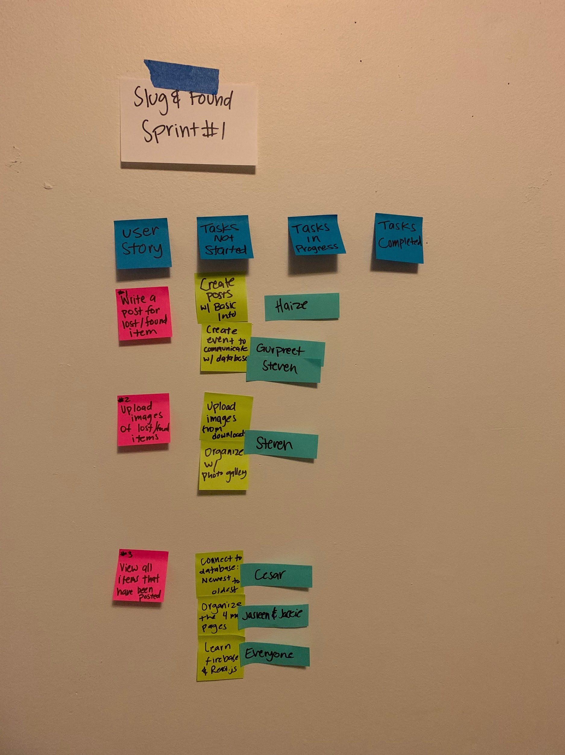

Scrum times:

Monday 4:30 - 5:15 pm

Wednesday 1:00 - 1:45 pm

Saturdays: 7-8 pm

TA meetings

Monday: 4:30-5:15pm

Wednesda: 1:00-1:45pm